GLY4930-Seminar 1 credit Course
Spring 2026
Instructor of Record: Dr. Mark Brenner
203 Williamson Hall
e-mail: brenner@ufl.edu
Phone: 352-392-7226
Description: This one credit course is based on weekly seminars in the Department of Geological Sciences. They take place 'live" in Bless Auditorium (Room 100 Williamson Hall) at 3:30 pm on Thursdays. The schedule can be found at:
https://geology.ufl.edu/seminar-series/
If you cannot attend the live lecture, a recorded version of the lecture will be sent via e-mail sometime on Thursday evening or whenever it is sent to me. You are expected to attend the seminar each week and complete a 1-2-page written summary.
Assignment - Repeated for each seminar. The following items should be in your report for each seminar (due date is midnight on Thursdays one week after each seminar). Please submit the assignment in Word, using 10-12 pt font and single spacing.
(1) Title of Talk and Name of Speaker, Date
(2) Your name
(Points 1 and 2 should be on a single line)
(3) One paragraph summary of the talk (What you got out of it).
(4) 1-2 paragraphs description about what data were used in support of the speaker's argument and a discussion about how convinced you were by the argument. For example, did the speaker just use jargon that made it difficult to understand, or were they logical and methodical in their approach?
(5) 1-paragraph opinion of the speaker. Were they convincing? Was the talk lively and enjoyable? Was the visual presentation useful and easy to follow?
(6) Give definitions for 3 terms that you did not know before the talk.
You should e-mail me (brenner@ufl.edu) the summary by the due date
Grading Scale:
93-100- A
90-92.99- A-
87-89.99- B+
83-86.99- B
80-82.99- B-
77-79.99- C+
73-76.99- C
70-72.99- C-
67-69.99- D+
63-66.99- D
60-62.99- D-
<60- E
Excused Absences: You can miss one seminar during the semester without any penalty to your grade. If you have extenuating circumstances and cannot submit your paper by the deadline, send me a quick note with a new deadline (you set this deadline but should not be more than 7 additional days).
A Note on the Speakers/Topics for the Seminar Course
Apparently, in the past, some students have provided negative reviews for this course because the speakers were hard to understand and/or because the topics were too complex. Please understand that the instructor of record simply facilitates this course for students who need 1 credit, and the grade is based on the papers you submit. The instructor of record does not choose the speakers or their topics. These talks are meant to be technical and are aimed at senior undergraduates, graduate students and faculty, and are part of our yearly academic seminar series. Such seminar series are common in academic circles. Ideally, speakers should strive to make the material easy to grasp for all students. Note that you are being asked for your opinion about how successful the speaker was in delivering their message. It is my hope that you will use this opportunity to learn about what makes a good versus a poor presentation. And be sure, I likely share your opinion about presentation quality. I will use Track Changes to comment on reports and will return them to you in a timely manner.

Native American Statement: The Department of Geological Sciences at UF respectively acknowledges the native Potano people and the Timucua tribe on whose land the UF campus now occupies.

Course Summary
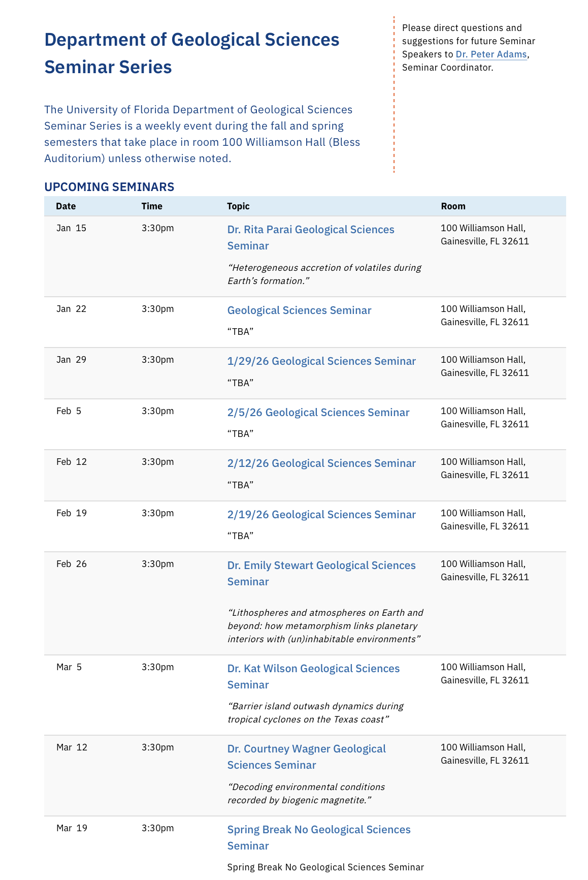
For further information on UF's Grading Policy, consult:
https://catalog.ufl.edu/ugrad/current/regulations/info/grades.aspx

COURSE AND UNIVERSITY POLICIES
Academic accommodations for students with disabilities

Students with disabilities who experience learning barriers and would like to request academic accommodations should connect with the disability Resource Center. Students can copy and paste the following link to obtain information about accommodations (https://disability.ufl.edu/get-started/). It is important for students to share their accommodation letter with their instructor and discuss their access needs, as early as possible in the semester.

Course evaluation process

Students are expected to provide professional and respectful feedback on the quality of instruction in this course by completing course evaluations online via GatorEvals. Guidance on how to give feedback in a professional and respectful manner is available at https://gatorevals.aa.ufl.edu/students/. Students will be notified when the evaluation period opens, and can complete evaluations through the email they receive from GatorEvals, in their Canvas course menu under GatorEvals, or via https://ufl.bluera.com/ufl/. Summaries of course evaluation results are available to students at https://gatorevals.aa.ufl.edu/public-results/.

Academic Honesty Policy

UF students are bound by The Honor Pledge which states, “We, the members of the University of Florida community, pledge to hold ourselves and our peers to the highest standards of honor and integrity by abiding by the Honor Code. On all work submitted for credit by students at the University of Florida, the following pledge is either required or implied: “On my honor, I have neither given nor received unauthorized aid in doing this assignment.” The Conduct Code specifies a number of behaviors that are in violation of this code and the possible sanctions. Go here to read the Conduct Code (https://sccr.dso.ufl.edu/process/student-conduct-code/). If you have any questions or concerns, please consult with the instructor or TAs in this class.

In-Class Recording

Students are allowed to record video or audio of class lectures. However, the purposes for which these recordings may be used are strictly controlled. The only allowable purposes are (1) for personal educational use, (2) in connection with a complaint to the university, or (3) as evidence in, or in preparation for, a criminal or civil proceeding. All other purposes are prohibited. Specifically, students may not publish recorded lectures without the written consent of the instructor.

A “class lecture” is an educational presentation intended to inform or teach enrolled students about a particular subject, including any instructor-led discussions that form part of the presentation, and delivered by any instructor hired or appointed by the University, or by a guest instructor, as part of a University of Florida course. A class lecture does not include lab sessions, student presentations, clinical presentations such as patient history, academic exercises involving solely student participation, assessments (quizzes, tests, exams), field trips, private conversations between students in the class or between a student and the faculty or lecturer during a class session.

Publication without permission of the instructor is prohibited. To “publish” means to share, transmit, circulate, distribute, or provide access to a recording, regardless of format or medium, to another person (or persons), including but not limited to another student within the same class section. Additionally, a recording, or transcript of a recording, is considered published if it is posted on or uploaded to, in whole or in part, any media platform, including but not limited to social media, book, magazine, newspaper, leaflet, or third party note/tutoring services. A student who publishes a recording without written consent may be subject to a civil cause of action instituted by a person injured by the publication and/or discipline under UF Regulation 4.040 Student Honor Code and Student Conduct Code.

Campus Resources

Health and Wellness

U Matter, We Care: If you or someone you know is in distress, please contact umatter@ufl.edu, 352-392-1575, or visit the We Care website (https://umatter.ufl.edu) to refer or report a concern and a team member will reach out to the student in distress.

Counseling and Wellness Center: Visit the Counseling and Wellness Center website (https://counseling.ufl.edu) or call 352-392-1575 for information on crisis services as well as non-crisis services.

Student Health Care Center: Call 352-392-1161 for 24/7 information to help you find the care you need, or visit the Student Health Care Center website (https://shcc.ufl.edu).
.

University Police Department: Visit UF Police Department website (https://police.ufl.edu)
or call 352-392-1111 (or 9-1-1 for emergencies).

UF Health Shands Emergency Room / Trauma Center: For immediate medical care call 352-733-0111 or go to the emergency room at 1515 SW Archer Road, Gainesville, FL 32608; Visit the UF Health Emergency Room and Trauma Center website (https://ufhealth.org/emergency-room-trauma-center).

Academic Resources

E-learning technical support: Contact the UF Computing Help Desk at https://helpdesk.ufl.edu, 352-392-4357 or via e-mail at helpdesk@ufl.edu.

Career Connections Center: Reitz Union Suite 1300, 352-392-1601. Career assistance and counseling services, https://career.ufl.edu.

Library Support: Various ways to receive assistance with respect to using the libraries or finding resources (https://uflib.ufl.edu/find/ask/).

Teaching Center: Broward Hall, 352-392-2010 or to make an appointment 352- 392-6420. General study skills and tutoring (https://teachingcenter.ufl.edu).

Writing Studio: 2215 Turlington Hall, 352-846-1138. Help brainstorming, formatting, and writing papers (https://writing.ufl.edu/writing-studio/).

Student Complaints On-Campus: Visit the Student Honor Code and Student Conduct Code webpage for more information (https://sccr.dso.ufl.edu/policies/student-honor-%20code-student-conduct-code/).

On-Line Students Complaints: View the Distance Learning Student Complaint Process (https://distance.ufl.edu/getting-help/student-complaint-process/).

